Claims Management System
Use Case Document


 | Prepared By | Last Updated By | Reviewed by | Approved By
Name | Satyansh Shukla | Rahul Kumar | Chandan Kumar Jha | Shriyans Nidhish
Role | Team Member | Team Member | Team Member | Scrum Master
Signature
Date | 22/03/2019 | 26/03/2019 | 26/03/2019 | 27/03/2019

Table of Contents
1.0 Introduction 3
1.1 Purpose & Scope of the document 3
1.2 Intended Audience 3
1.3 Use case ‘Admin Registration’ 3
1.3.1 Use case attributes 3
1.3.2 Use Case Model 4
1.3.3 Business Rules 4
1.3.4 UI Requirements 5
1.3.5 UI Field Validations 6
1.4 Use case ‘Admin Credential Authentication’ 6
1.4.1 Use case attributes 6
1.4.2 Use Case Model 8
1.4.3 Business Rules 8
1.4.4 UI Requirements 8
1.5 Use case ‘Member Registration’ 9
1.5.1 Use case attributes 9
1.5.2 Use Case Model 10
1.5.3 Business Rules 10
1.5.4 UI Requirements 11
1.5.5 UI Field Validations 12
1.6 Use case ‘Member Credential Authentication’ 12
1.6.1 Use case attributes 12
1.6.2 Use Case Model 14
1.6.3 Business Rules 14
1.6.4 UI Requirements 14
2.0 Database Design 15
2.1 Tables Structure 15
3.0 Change Log 18

Introduction

Purpose & Scope of the document
The purpose of this Use case document is to systematically capture requirements for the project and the system to be developed in terms of use cases. Functional use cases are captured in this document. It also serves as the input for the project scoping.

The scope of this document is limited to addressing the use cases from a user, quality, and non-functional perspective.

Intended Audience
Each member of the project team

Use case ‘Admin Registration’

Use case attributes
Use Case Description:

This use case deals with the capture of Admin details. The ‘Admin’ here shall be the operator of the system and will be keying in the Members information into the system.

Scope:

- Admin registration

Actors:

- Admin – the operator

Trigger:

Click ‘Register’ button in the ‘Admin Registration’ page

Pre-Condition:

Admin being able to access the homepage & get redirected to the ‘Admin Registration’ page upon click of ‘Admin Registeration’ link.

Post Condition:

Admin is in the registration page & submit details.

Flow of Events:

Admin at homepage → Click ‘Admin Registration’ link → Admin is in the registration page → Admin details are submitted and added onto the database

Primary Scenario:
A new Admin – is able to click ‘Admin Registration’ link and able to provide his/her details and get registered in the system.

Use Case Model
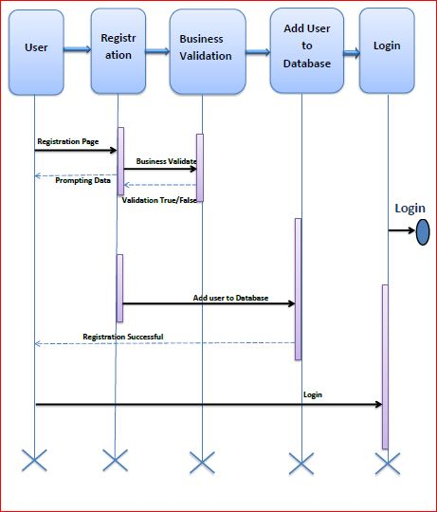

Business Rules

Business rules should be defined using the following attributes: -

- When the Admin clicks on the registration link, it should re-direct to admin registration form.
    - Admin needs to fill some of the basic attributes/fields as mentioned below in requirement: First Name, Last Name, Age, Gender, Contact Number, Alternate number, email, Password.
- Clicking ‘Register’ should validate the datatype constraints for each field
- Post-successful field level validation, save the information in the database
- Upon saving the information in the database, display the message ‘Your details are submitted successfully’ with the system generated ‘Admin-ID’.

UI Requirements
Here is a prototype on how the homepage should look like.



Here is a prototype on how the ‘Admin Registration’ page should look like.

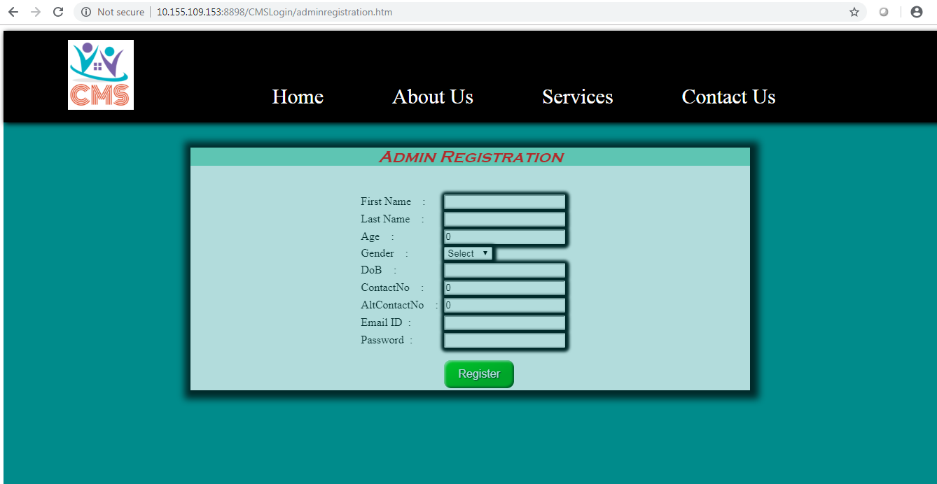

UI Field Validations
Please refer to the below requirements for field level validations:

- All fields are mandatory.
- Age should be between 18 and 120.
- DoB should be in dd/mm/yyyy format.
- Password should contain at least 1 upper case, 1 special character, 1 digit, and the length should be between 8 to 12 characters.
- The Email ID format must be checked. (For ex. test@testmail.com.)
- Contact No and AltContact No must be of 10 digits’ length

Use case ‘Admin Credential Authentication’

Use case attributes
Use Case Description:

This use case deals with the authentication of the admin credentials. The ‘admin’ here shall be the operator of the system and will be managing the claims raised by the members.

Scope:

- Admin credentials authentication

Actors:

Admin – the operator

Trigger:

Click ‘Login’ link, after keying in ‘Admin-ID’ & ‘Password’ field.

Pre-Condition:

Admin being able to access the homepage

Post Condition:

Admin is in the admin’s dashboard.

Flow of Events:

Admin at homepage → Key in ‘Admin-ID’ & ‘Password’ field → Admin credentials are validated → dashboard is displayed.

Primary Scenario:
A registered Admin – is able click ‘Login’ link, after keying in ‘Admin-ID’ & ‘Password’ field and get his credentials authenticated with the existing database entry.

Alternative Scenario:
A registered Admin – is able click ‘Login’ link, after keying in ‘Admin-ID’ & ‘Password’ field and unable to get his credentials authenticated. The admin is presented with relevant error messages:

- Invalid admin-ID or password – ‘Username or password error’.

Use Case Model

Business Rules
Business rules should be defined using the following attributes: -

- A registered Admin – is able click ‘Login’ link, after keying in ‘Admin-ID’ & ‘Password’ field and get his credentials authenticated with the existing database entry.

UI Requirements
Here is a prototype on how the admin dashboard should look like.

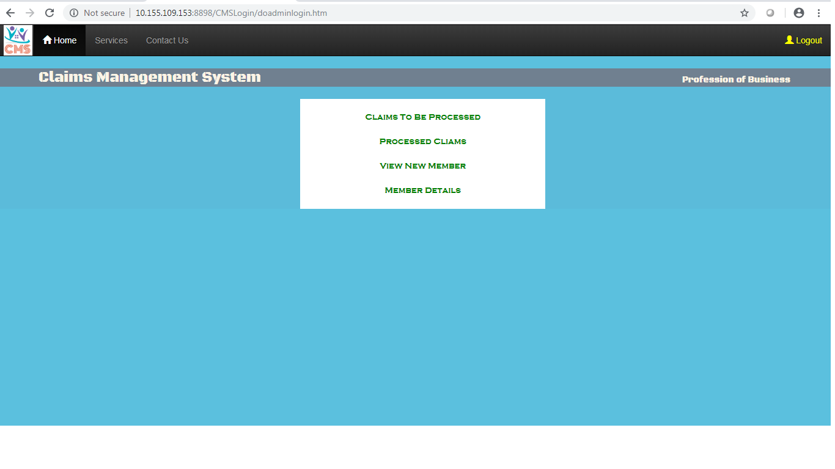

Use case ‘Member Registration’

Use case attributes
Use Case Description:

This use case deals with the capture of Member details. The ‘Member’ here shall be the operator of the system and will be raising the claims information into the system.

Scope:

- Member registration

Actors:

- Member – the operator

Trigger:

Click ‘Register’ button in the ‘Member Registration’ page

Pre-Condition:

Member being able to access the homepage & get redirected to the ‘Member Registration’ page upon click of ‘Member Registration’ link.

Post Condition:

Member is in the registration page & submit details.

Flow of Events:

Member at homepage → Click ‘Member Registration’ link → Member is in the registration page → Member details are submitted and added onto the database

Primary Scenario:
A new Member – is able to click ‘Member Registration’ link and able to provide his/her details and get registered in the system.

Use Case Model

Business Rules

Business rules should be defined using the following attributes: -

- When the member clicks on the registration link, it should re-direct to member registration form.
    - Member needs to fill some of the basic attributes/fields as mentioned below in requirement: First Name, Last Name, Age, Gender, Contact Number, Alternate number, email, Password, coverage start date, coverage end date, plan code, address, city, zip code, state.
- Clicking ‘Register’ should validate the datatype constraints for each field
- Post-successful field level validation, save the information in the database
- Upon saving the information in the database, display the message ‘Your details are submitted successfully’ with the system generated ‘Member-ID’.

UI Requirements
Here is a prototype on how the homepage should look like.

Here is a prototype on how the ‘Member Registration’ page should look like.

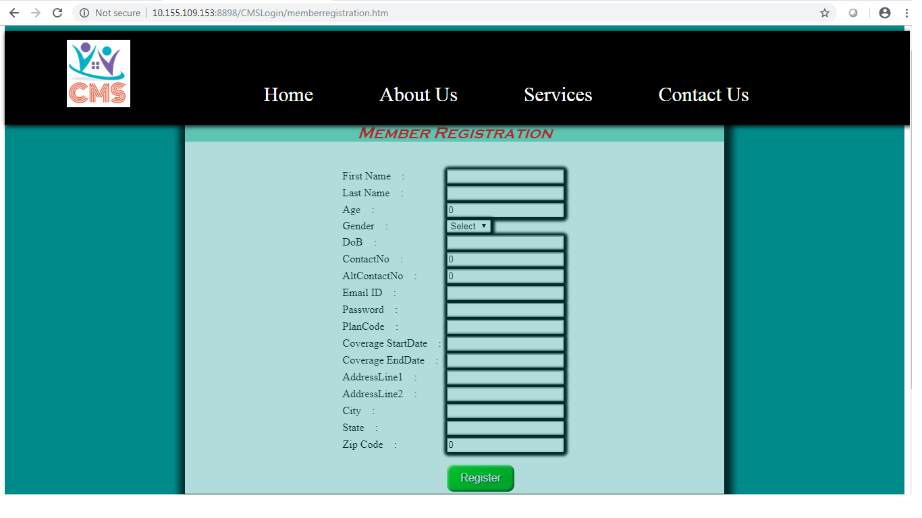

UI Field Validations
Please refer to the below requirements for field level validations:

- All fields are mandatory.
- Age should be between 18 and 120.
- DoB should be in dd/mm/yyyy format.
- Password should contain at least 1 upper case, 1 special character, 1 digit, and the length should be between 8 to 12 characters.
- The Email ID format must be checked. (For ex. test@testmail.com.)
- Contact No and AltContact No must be of 10 digits’ length
- Plan code should be of 6 digits only.
- Coverage Date should be in dd/mm/yyyy format.
- End Date should be in dd/mm/yyyy format.

Use case ‘Member Credential Authentication’

Use case attributes
Use Case Description:

This use case deals with the authentication of the admin credentials. The ‘Member’ here shall be the operator of the system and will be raising the claims information into the system.

Scope:

- Member credentials authentication

Actors:

Member – the operator

Trigger:

Click ‘Login’ link, after keying in ‘Member-ID’ & ‘Password’ field.

Pre-Condition:

Member being able to access the homepage

Post Condition:

Member is in the member’s dashboard.

Flow of Events:

Member at homepage → Key in ‘Member-ID’ & ‘Password’ field → Member credentials are validated → dashboard is displayed.

Primary Scenario:
A Member Admin – is able click ‘Login’ link, after keying in ‘Member-ID’ & ‘Password’ field and get his credentials authenticated with the existing database entry.

Alternative Scenario:
A registered Member – is able click ‘Login’ link, after keying in ‘Member-ID’ & ‘Password’ field and unable to get his credentials authenticated. The Member is presented with relevant error messages:

- Invalid member-ID or password – ‘Username or password error’.

Use Case Model

Business Rules
Business rules should be defined using the following attributes: -

- A registered Member – is able click ‘Login’ link, after keying in ‘Member-ID’ & ‘Password’ field and get his credentials authenticated with the existing database entry.

UI Requirements
Here is a prototype on how the Member dashboard should look like.

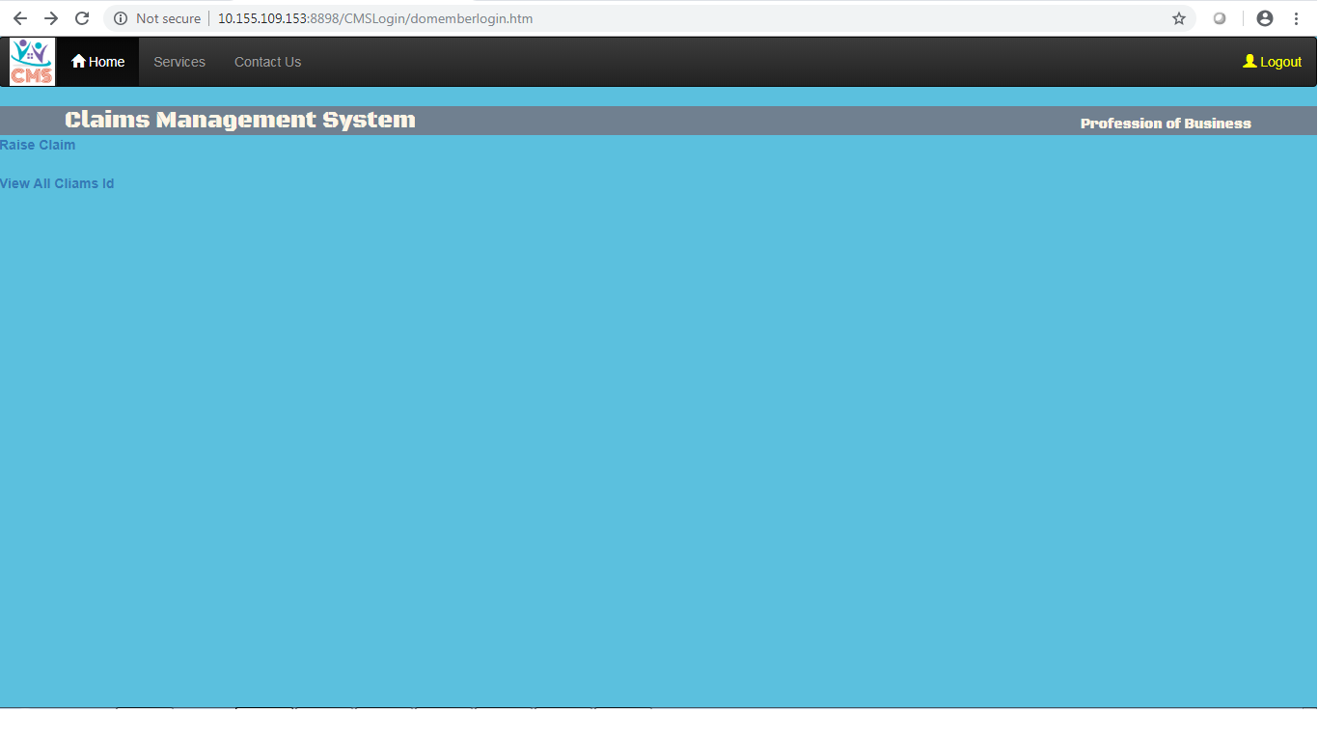

Database Design

Tables Structure
Admin Registration:

Column Name | Field Type | Data Type | Mandatory | Possible Values
Admin Id | Text(10) | Alphabetic | Yes | System Generated
First Name | Text(10) | Alphabetic | Yes
Last Name | Text(10) | Alphabetic | Yes
Age | Number(2) | Numeric | Yes
Gender | Drop Down | NA | N | Male,female
DOB | Text(10) | Alphanumeric | Yes
Contact Number | Text(10) | Numeric | Yes
Alt Contact | Text(10) | Numeric | No
Email ID | Text(10) | Alphanumeric | Yes

Member:
Field Name | Field Type | Data Type | Mandatory | Possible values
Member ID | Text(10) | Alphabetic | Yes | System Generated
First Name | Text(50) | Alphabetic | Yes
Last Name | Text(50) | Alphabetic | Yes
Age | Numeric(2) | Numeric | Yes
Gender | Drop Down | NA |  | Male, female
DoB | Text(10) | Alphanumeric | Yes
Contact No | Text(10) | Numeric | Yes
Alt Contact No | Text(10) | Numeric | No
Email ID | Text(50) | Alphanumeric | Yes
Password | Text(50) | Alphanumeric | Yes
Plan Code | Text(15) | Alphanumeric | Yes
Coverage Start Date | Test(10) | Alphanumeric | Yes
Covergae End Date | Text(10) | Alphanumeric | Yes
Address Line 1 | Text(100) | Alphanumeric | Yes
Address Line 2 | Text(100) | Alphanumeric | Yes
City | Text(20) | Alphanumeric | Yes
State | Text(15) | Alphanumeric | Yes
Zip Code | Text(10) | Alphanumeric | Yes

Claim:
Field Name | Field Type | Data Type | Mandatory | Possible Values
Clam ID | Auto Generated(5) | Numeric | Yes | System Generated
Member ID | Text(10) | Alphabetic | Yes | System Generated
Claim Service Date | Text(10) | Alphanumeric | Yes
Claim Submission Date | Text(10) | Alphanumeric | Yes
Claim Processing Date | Text(10) | Alphanumeric | Yes
Claim Status | Text(10) Drop Down | Alphabetic | Yes | Submitted,  Approved  Denied
Claim Amount | Numeric(10) | Numeric | Yes | Default 0
Approved Amount | Numeric(10) | Numeric | Yes | Default 0

Change Log
Version Number | Changes Made
V1.0 | Initial baseline created on <22-MAR-19> by <Satyansh Shukla>
V1.1
V1.1 | Section No. | Changed By | Effective Date | Changes Effected
V1.1 | 1.3 | Satyansh Shukla | 23/03/2019 | Use case attributes, model, UI Field Validations.
V1.1 | 1.5 | Satyansh Shukla | 23/03/2019 | Use case attributes, model, UI Field Validations.
V1.1 | 1.4 | Chandan Kumar | 25/03/2019 | Use case attributes and UI requirements.
V1.1 | 1.6 | Chandan Kumar | 25/03/2019 | Use case attributes and UI requirements.

